**DOMINICAN COLLEGE OF TARLAC**

Mac Arthur Highway, Poblacion (Sto.Cristo), Capas. 2315 Tarlac, Philippines

Tel.No. (045) 491-7579/Telefax (045) 925-0519

E-mail: domct _2315@yahoo.com

**COLLEGE DEPARTMENT**

A.Y. 2020-2021, First Semester

**OBE FACULTY - DESIGNED MODULE**



**THE CONTEMPORARY WORLD**

1. **Subject: GE3 - The Contemporary World**
2. **Learning Outcomes:**

-Define Contemporary Global Governance  
-Identify the institutions that govern international relations.  
-Appreciate the functions of different organizations that govern the world.

1. **Topic/Lesson:** Contemporary Global Governance
2. **Days of Learning Sessions:**

**Online/Modular**

BSCRIM 1A - Friday/Wednesday

BSCRIM 1B - Wednesday/Friday

BSCRIM 1C - Thursday/Saturday

1. **Expected Outcome:**

Distinguish the purpose of Global Governance

**VI.Delivery:**

1. **Thought Processing**
   1. **Pre-assessment Activity (Collaboration)**

**Describe and interpret the image below.**

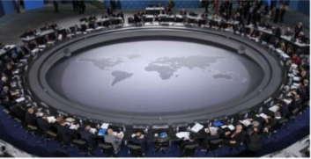

_________________________________________________________________________________________________________________________________________________________________________________________________________

1. **Presentation Phase:**

**The 3-A Approach**

* 1. **ANALYSIS (Communication)**

**Activity:** Explain the relevance of the image in activity 1 to global governance.

________________________________________________________________________________________________________________________________________________________________________________________________________________________________________________________________________________________________________________________________________________________________________________________________________________________________________________________________

* 1. **ABSTRACTION (Critical Thinking)**

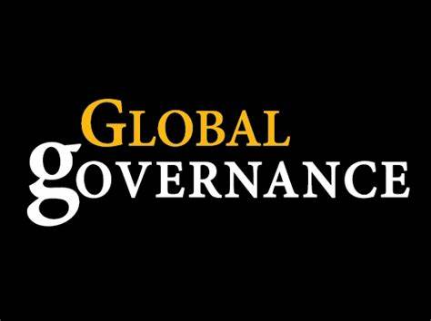**Contemporary Global Governance**

(or world governance) is a purposeful order that emerges from institutions, processes, norms, formal agreements, and informal mechanisms that regulate action for a common good.

**Contemporary -**

marked by characteristics of the present period: MODERN, CURRENT

**International Organizations**

an institutional agreement between members of an international system in order to achieve objectives according to systemic conditions, reflecting attributes, aspirations and concerns of its members

Notable examples include the United Nations (UN), Organization for Security and Co-operation in Europe (OSCE), Council of Europe (COE), International Labour Organization (ILO) and International Police Organization (INTERPOL).

**Types of International Organization**

* Inter-Governmental Organizations (IGO's)
* International Non-Governmental Organizations (NGO's)
* Multinational Enterprises.

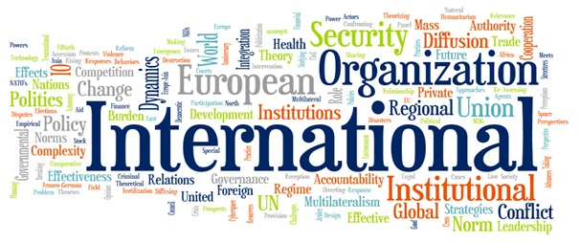

***Intergovernmental Organization (IGO)***

an organization composed primarily of sovereign states or of other intergovernmental organizations.

IGOs are established by a treaty that acts as a charter creating the group.

Intergovernmental organizations differ in function, membership, and membership criteria. They have various goals and scopes.

**Some of the examples are:**

* ***United Nations***

-To maintain international peace and security

-To develop friendly relations among nations

-Open to all other peace-loving states

**Privileges and immunities**

Convention on the Privileges and Immunities of the United Nations

Agreement on the Privileges and Immunities of the International Criminal Court

International Organizations Immunities Act

Employment law

* 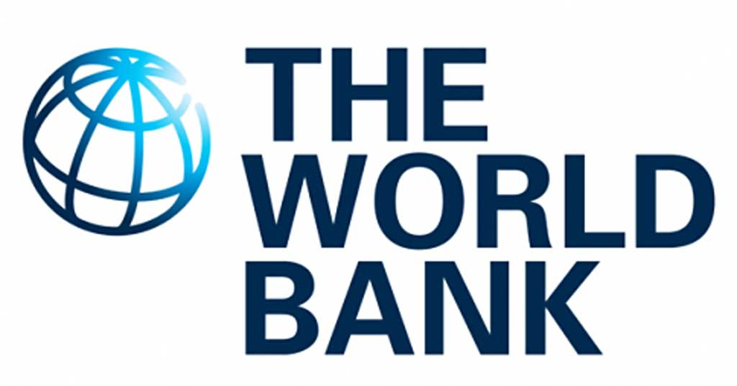**World Bank**

-End extreme poverty

-Promote shared prosperity

-has 189 member countries

* 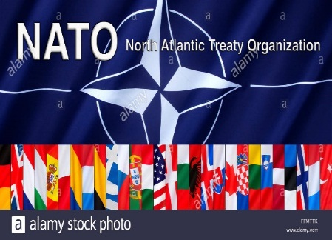**North Atlantic Treaty Organization**

-They are determined to safeguard the freedom, common heritage and civilisation of their peoples

-They seek to promote stability and well-being in the North Atlantic area.

-NATO is an Alliance that consists of 29 independent member countries.

**Strengths**

They hold state authority.

Their institutions are permanent.

They provide a forum for discussion.

They are issue-specific.

They provide information.

They allow multilateral co-operation.

**Weaknesses**

Membership is limited.

IGOs often overlap, resulting in an overly complex network.

States have to give up part of their sovereignty.

**International Non-Governmental Organizations**

A non-governmental organization (NGO) is a non-profit, citizen-based group that functions independently of government.

Organized on community, national and international levels to serve specific social or political purposes, and are cooperative, rather than commercial, in nature.

NGOs are independent of governments and can be seen as two types, advocacy NGOs, and operational NGOs

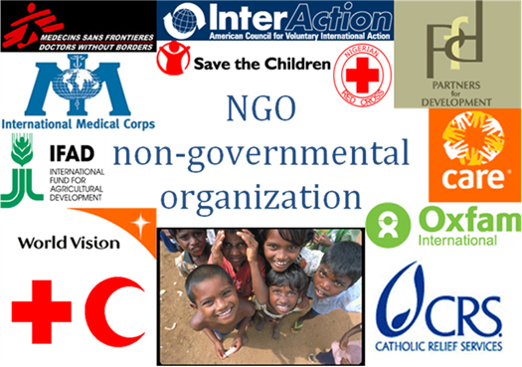

**How NGOs are Funded?**

As non-profits, NGOs rely on a variety of sources for funding, including:

membership dues

private donations

the sale of goods and services

grants

**Types of NGOs**

A number of NGO variations exist, including:

**BINGO:** Business-friendly International NGO

**ENGO:** Environmental NGO

**GONGO:** Government-Organized Non-Governmental Organization

**INGO:** International NGO

**QUANGO:** Quasi-Autonomous NGO

**Multinational Enterpises**

A multinational corporation (MNC) or worldwide enterprise is a corporate organization that owns or controls production of goods or services in at least one country other than its home country.



**TWO FEATURE THAT MAKE THE DIFFERENCE BETWEEN INTERNATIONAL ORGANIZATION AND OTHER ORGANIZATION**

- Centralization of power

- Decision making autonomy

Both have political effects beyond the simple effectiveness of the taken decision because they resemble so much with governments or private companies

**ROLE OF INTERNATIONAL ORGANIZATION**

- Carry out actions that enjoy legitimacy and affect the legitimacy of the state activity

- Participate as independent and neutral actors on global stage

- Can take decisions that bind on member states through predictable mechanism and pursuing their interests.

**Basic Functions and Structure of United Nations**

***Functions and Powers***

Under the United Nations Charter, the functions and powers of the Security Council are:

* To maintain international peace and security in accordance with the principles and purposes of the United Nations;

**STRUCTURE**

Six Principal organs of the UN:

The General Assembly

The Security Council

The Economic and Social Council

The Trusteeship Council

The International Court of Justice

The Secretariat

* To investigate any dispute or situation which might lead to international friction;
* to recommend methods of adjusting such disputes or the terms of settlement;
* to formulate plans for the establishment of a system to regulate armaments;
* to determine the existence of a threat to the peace or act of aggression and to recommend what action should be taken;
* to prevent or stop aggression;
* to take military action against an aggressor;

***The General Assembly***

Main Function: Assessing member countries and deciding on the budget

The only organ where member state is represented

Consists of committees

Convenes annually in September, special sessions can also be held

Voting on important questions or recommendations on peace & security, budgetary concerns and the election, admission, or suspension of members - is by a two-thirds majority of those present and voting

***The Security Council***

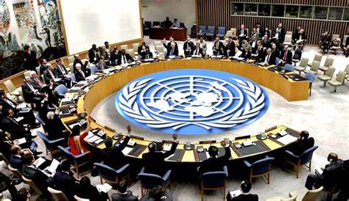UN's most powerful organ  
It deals with threats to int'l peace and security   
Its powers include the establishment of peacekeeping operations & international sanctions, and the authorization of military action  
It has 15 members,5 are permanent  
Permanent members have veto power when council decides on important issues

Central platform for debate and innovative thinking on sustainable development

The Principal body for coordination, policy review, policy dialogue and recommendations on economic, social and environmental issues.

ECOSOC engages a wide variety of stakeholders

The work of the Council is guided by an issue-based approach

***The Economic and Social Council (ECOSOC)***

***The Trusteeship Council***

Established to help ensure that trust territories were administered in the best interests.

Authorized to examine and discuss reports from the Administering Authority.

In consultation with the Administering Authority, to examine petitions from and undertake periodic and other special missions to Trust Territories.

***The International Court of Justice***

The Principal judicial organ of the UN

Based in Hague, Netherlands

Consists of 15 judges/seats elected by the General Assembly and Security Council

Applies international law

Main Function: To settle legal disputes and To provide advisory opinions on legal questions

No appeals can be made by parties to its judgement

***The Secretariat***

Primarily has an administrative function

Includes an international staff working in duty stations around the world.

The Secretary General Hold office for five years per term

Current Secretary General is Antonio Guterres

It services the other principal organs of the United Nations and administers the programmes and policies ;aid down by them

**Activity: In your own words, fill out the table by stating the significance of the terms provided to the contemporary world.**

|  |  |
| --- | --- |
| **International Organization** | **Signifiance to the Contemporary World** |
| 1. **UNITED NATIONS** |  |
| 1. **WORLD BANK** |  |
| 1. **NORTH ATLANTIC TREATY ORGANIZATION** |  |
| 1. **INTERNATIONAL POLICE ORGANIZATION** |  |

* 1. **APPLICATION (Creativity):**

**Activity: In your opinion, what improvements/revisions should be done to the implementation of global governance, justify your answer briefly.**

_____________________________________________________________________________________________________________________________________________________________________________________________________________________________________________________________________________________________________________________________________

1. **Assessment Phase:**
2. **Quiz: To retain what you have learned, complete the table by writing the main function of the organizations listed below.**

|  |  |
| --- | --- |
| **International Organization** | **Functions** |
| 1. **UNITED NATIONS** |  |
| 1. **WORLD BANK** |  |
| 1. **NORTH ATLANTIC TREATY ORGANIZATION** |  |
| 1. **INTERNATIONAL POLICE ORGANIZATION** |  |

1. **Take Home Tasks/ Suggestive Readings:**

Read articles about World of Regions

**VII. Reference/s:**

The Contemporary World by **Prince Kennex Reguyal Aldama,** published by REX Book Store, 2018